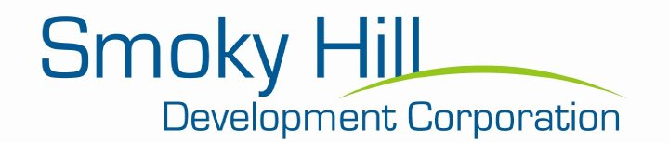
P.O. Box 321 * 114 ½ N. Douglas Ave. * Ellsworth, KS 67439 * Phone (785)810-8303
Email: Smokyhilldevcorp@gmail.com
SMOKY HILL DEVELOPMENT CORPORATION FACADE IMPROVEMENT PROGRAM

Purpose – This program is designed for small scale renovation projects to the façade of the buildings in Ellsworth County. The program is available to provide an affordable financing option for improvements to commercial building facades in order to improve the functionality, structural integrity, and aesthetics in commercial areas.
Applicant Eligibility –
- Building must be located in Ellsworth County.
- Building owner must be the program applicant; or business manager with business owner letter approving proposed façade improvements.
- Project must comply with applicable city, building, electrical, mechanical codes and have a valid permit.
- The applicant must have 2 of the following 3:
- A credit score of 700
- Been in business for 1 year
- Provide matching funds for 1:1 of the requested amount
Eligible Use of Funds – Funding will only be approved for exterior improvements only. Projects may include but are not limited to:
- Building expansion
- Window repair and replacement
- Vacant building redevelopment
- Canopy or awning replacement, repair, or installation
- Signage – not more than 30% of the funds can go towards signage
- Removal of contemporary facades to expose original construction of building
- Repair and/or tuck point existing structures
- Repair or replacement of siding, trim, windows, doors, and awnings
- Exterior painting, pressure washing, sand blasting
- Exterior lighting
- No interior renovations, but may consider heating/air/energy efficiency projects
Requirements Include –
- All projects awarded must be completed within one calendar year from the official date of the award letter
- No debt refinance
- Quotes for work to be completed
Loan Terms and Repayment –
- Maximum loan of $5,000, minimum loan of $3,000
- Interest rate fixed at 0%
- Maximum loan term of 10 years
- Closing fee of 1% to cover NCRPC expenses of administering the program
- The loan will be paid in equal monthly installments by ACH draft from the applicants
Application period is open and on a first come, first serve basis with no deadlines, based on the availability of funds.
Contact: Stacie Schmidt, Executive Director of Smoky Hill Development Corporation
smokyhilldevcorp@gmail.com

