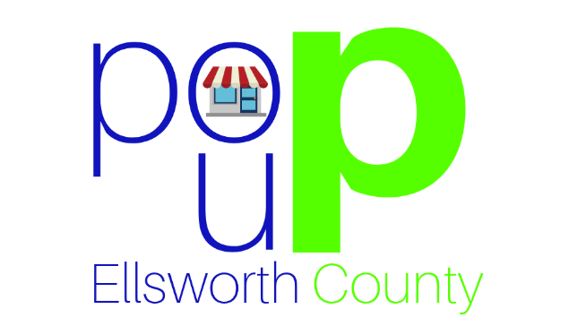
POP-UP ELLSWORTH COUNTY
LANDLORD APPLICATION
POP Up Ellsworth County is a program run by Smoky Hill Development Corporation towards the Grow Ellsworth County Initiative. The goal of POP Up Ellsworth County is to bring together entrepreneurs and businesses to activate storefronts, enhancing the retail community within Ellsworth County. It is also a hope that the initiative will encourage business owners to revitalize their properties, potentially finding a long-term lease or purchase match, and contribute to the vitality of Ellsworth County.
By donating or leasing your vacant storefronts for short periods of time, your property receives exposure and publicity, increased foot traffic, and extra revenue while searching for a long-term tenant or purchaser. The ultimate goal of the program is to establish permanent business, and reduce vacant or unused commercial space within downtown business districts in Ellsworth, Wilson, Holyrood, Kanopolis, and Lorraine.
If you have retail or office space available and would like to be considered for a POP Up Location, please complete the below form. Please submit the completed form to Smoky Hill Development Corporation, PO Box 321, Ellsworth, KS 67439 or to smokyhilldevcorp@gmail.com.

Name: __________________________________________________________________________
Email: ________________________________________Phone: _____________________________
Property Address: _________________________________________________________________
What floor is your space on? __________ How many square feet? ______________________
How many restrooms does your space offer? ____________

** Additional information, including conditions, what types of space you are willing to consider, photos, and terms will be negotiated on a case-by-case basis via personal interview. This application is only to determine interested parties.**

